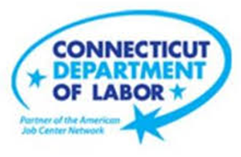

**NEW WEEKLY JOB POSTINGS FROM   
HELP WANTED ONLINE  
Office of Research**

**Week Ending February 6th, 2021  
New Ads Down 4% Over The Week, Driven by Declines in Health Care & Social Assistance**

WETHERSFIELD, February 11th, 2021 – During the week ending February 6th, 2021, there were 3,950 new postings, down 4% from a week ago. This overall decline was driven by Health Care & Social Assistance, down 295 new ads or 33%. The overall new ad count of 3,950 is down 1,647 ads from the January high of 5,597 which occurred during the week ending January 16th. 57 percent of that three-week decline occurred in Retail Trade (-512 new ads over three weeks) and Health Care and Social Assistance (-436 new ads over three weeks). The employers with the largest new ad decline from that January peak include Petco and Hartford Healthcare. Employers that have added jobs since that peak include Raytheon (+34 new ads), Ernst & Young (+26 new ads), Yale University (+20 new ads) and Dattco Travel (+20 new ads).  
  
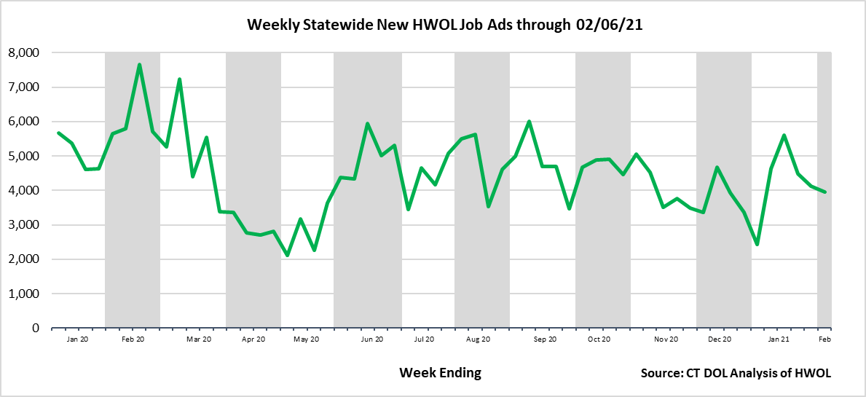

**Industries** with the most new postings include Health Care & Social Assistance, Retail Trade, and Manufacturing

**Occupations** with the most new postings include Retail Salespersons, All Other Computer Occupations, and Sales Representatives, Wholesale & Manufacturing.

**Employers** with the most new postings include the State of Connecticut, Raytheon, and Lowe’s Companies, Inc.

**The three industries with the most new job postings where**

* **Health Care and Social Assistance** (595 new postings, -33% over the week)
* **Retail Trade** (399 new postings, -12% over the week)
* **Manufacturing** (396 new postings, -2% over the week)

­   
 Fourteen sectors had job posting decreases over the week and seven had increases. The statewide over the week decline of -168 across all sectors is the result of decreasing industries down a combined 469 ads and the seven increasing industries up 301. The largest sector declines occurred in Health Care & Social Assistance (-295 new ads or -33%) and the largest increase occurred in Real Estate & Rental (+48 new ads or +96%).  
  
 For more information on total job ads by industry for Connecticut and its labor market areas, see the monthly report available here: <https://www1.ctdol.state.ct.us/lmi/hwol.asp>

**New Job Postings by Occupation**

**The occupations with the most new postings were:**

* Retail Salespersons (127 new postings, +17% over the week)
* Computer Occupations, All Others (119 new postings, -9% over the week)
* Sales Representatives, Wholesale & Manufacturing (115 new postings, -3% over the week)



**Employers with the Most New Job Postings**

Employers with the most new job postings during the week ending February 6th, 2021 were mostly in Finance & Insurance, Health Care, and Retail Trade. The 25 employers shown above account for 20 percent of all new ads. Of the top 25 employers, 16 had over the week increases, one was unchanged, and 8 had decreases. The 16 increasing employers had a combined 288 new ad increase, the largest occurred in Lowe’s Companies (+36 new ads) and CDS Corporate (+33 new ads). Among the 8 decreasing employers in the top 25, 70 percent of over the week declines occurred in CVS Health (-106 new ads) and Hartford Healthcare (-110 new ads).   
 **Covid-19 and Weekly New Job Postings**  
In recent months, the pandemic Coronavirus (Covid-19) has caused significant social and economic implications throughout the world. This HWOL report includes new weekly job postings to illustrate how Covid-19 has impacted Connecticut in the short term and highlight recent job postings in the weeks since the virus disrupted both the economy and labor markets.  
  
**What is HWOL?**The **Conference Board Help Wanted Online**® Data Series (HWOL) measures the number of new, first-time Online job postings and jobs reposted from the previous month for over 16,000 Internet job boards, corporate boards and smaller job sites that serve niche markets and smaller geographic areas.

**To view more HWOL data, go to:** [**https://www1.ctdol.state.ct.us/lmi/pubs/HWOL2020.pdf**](https://www1.ctdol.state.ct.us/lmi/pubs/HWOL2020.pdf)